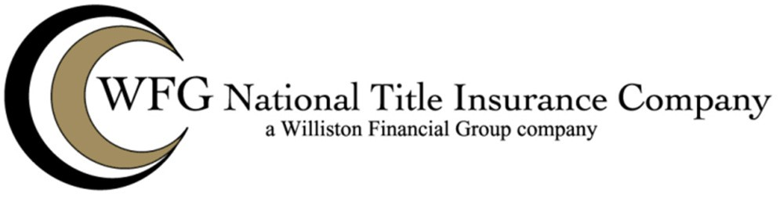

SECONDARY MORTGAGE MARKET ENDORSEMENT

Attached To and Made a Part of Loan Policy No. _

Issued By

WFG NATIONAL TITLE INSURANCE COMPANY

The Company insures that:

- Exception(s) set forth in Schedule B, Part I, if any, do not adversely affect the use and enjoyment of the premises for residential purpose as currently improved.

- Restriction(s), covenant(s) and condition(s) set forth in Schedule B, Part I, if any, have not been violated, and future violations will not result in forfeiture or reversion of title.

- Taxes, water and sewer use charges, and other municipal liens, if any, are not yet due and payable.

The total liability of the Company under said policy and under this and any prior endorsements thereto shall not exceed, in the aggregate, the amount of liability stated on the face of said policy as the same may be specifically amended in dollar amount by this or any prior endorsements, and the costs which the Company is obligated to pay under the Conditions and Stipulations of the policy.

This endorsement is made a part of the policy and is subject to all of the terms and provisions thereof and of any prior endorsements thereto. Except to the extent expressly stated, it neither modifies any of the terms and provisions of the policy and any prior endorsements, nor does it extend the effective date of the policy and any prior endorsements, nor does it increase the face amount thereof.

This Endorsement is valid only when it bears an authorized countersignature,

Signed under seal for the Company, this day of , 20

WFG National Title Insurance Company

By:

Authorized Signatory

